VIDEO GAME DESCRIPTION

INTRODUCTION:

* How often do you play videogames?
* Do you play on the computer, on a game console or on the mobile phone/tablet?
* What is your favourite type of videogames?

VOCABULARY:

General vocabulary

Find the Spanish meaning for these words. Atención, encontrar los significados relacionados al video juego.

|  |
| --- |
| * http://2.bp.blogspot.com/_CEo7jG-OiRA/TSUQKpKwT7I/AAAAAAAAAQI/lNeUIwRUIE8/s1600/chun%2Bli.jpgAntagonist * Arcade game * Boss * Characters * Cheats * Educational game * http://1.bp.blogspot.com/-dkPmgA5rrs4/TtfvmjoasiI/AAAAAAAAAhY/Ku-l92wkjhY/s1600/samus-aran-imagen.jpgFirst person shooter * Gameplay * Gamer * Main character or protagonist * MMOG (Massively Multiplayer Online Game) * MMORPG (Massively Multiplayer Online Role-Playing Game) * http://www.zelda-solarus.com/images/uploads/tp_link_jeune.jpgOpen world game * Platform game * Power up * Quest * Rating * Shooter * Strategy games * Third person game   ¿Agregarías más palabras a este listado? ¿Cuáles? |

Video game genres

Find the Spanish meaning for these words.

Video games genres are game types based on the way players interact with the game.

* Action
* Adventure
* Action-adventure
* Cooperative
* Puzzle
* Racing
* Roleplaying
* Sandbox
* Setting
* Simulation
* Sports
* Strategy

Find images to illustrate the genres.

¿Qué es una descripción? Es un texto oral o escrito que hace referencia a una persona, lugar cosa, etc. de tal manera que quien lo lee o escucha puede formarse una imagen de lo que se describe. En el texto descriptivo se usan sustantivos, adjetivos y adverbios para lograr este fin.

* **Un adjetivo** es una palabra que modifica al sustantivo:

An **exciting** game, **superior** powers, the **villainous** Doctor Neo Cortex

Esto quiere decir que agrega más detalles sobre el sustantivo. En inglés lo más común es que el adjetivo esté adelante del sustantivo en la oración (primero el adjetivo y después el sustantivo):

The game includes **new** moves and **old** friends.

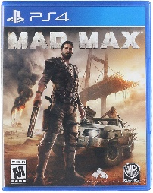Sonic is an **anthropomorphic** hedgehog.

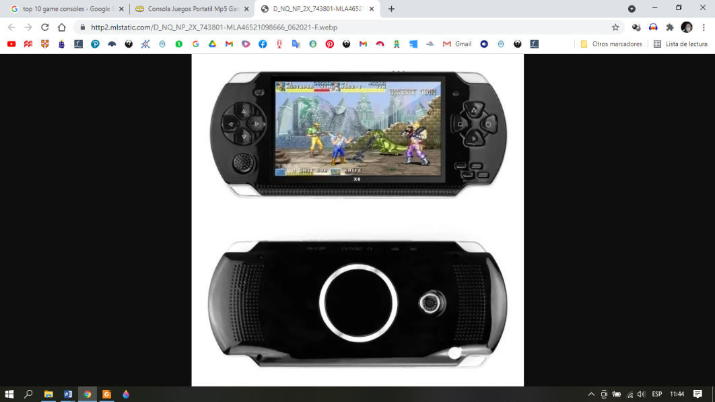Sin embargo los adjetivos también se pueden ubicar después de verbos como ‘be’ o ‘look’:

Mad Max looks **crazy**.

This game console is **fantastic.**

* Similar a un adjetivo, **un adverbio** describe o da más información sobre una acción, pero también puede modificar a un adjetivo o a otro adverbio, o a una oración completa:

Mario can jump and spin his body **simultaneously** like a tornado.

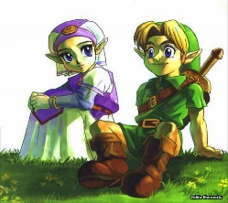Mortal Kombat is an **incredibly** violent game.

Hylians **traditionally** have pointed ears, and they **generally** have blue eyes.

Un adverbio de uso muy común es ‘**very**’:

This is a very exciting game.

Very puede ser reemplazado por really or incredibly para dar énfasis a la idea:

This is a **really** exciting game.

This is an **incredibly** exciting game.

Con toda esta información ya podemos ir introduciéndonos en las descripciones de diferentes juegos. Las mismas serán muy cortitas y sencillas, acordes con el inglés que aprendimos hasta ahora.

Estas descripciones tienen la siguiente estructura:

1. Veamos entonces cómo armar oraciones para señalar el nombre y género o tipo de juego. Esta es la parte más simple porque la estructura es:

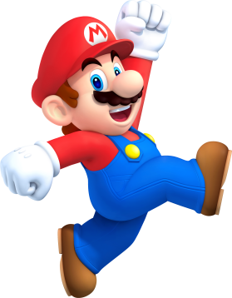 S (name of the game) + be + a/ an + type of game:

↓ ↓ ↓ ↓

Super Mario Bros is a platform game.

Super Mario Bros is a fantasy/action platform game.

Red Dead Redemption is an action adventure video game.

Resident Evil is a survival/ action game.

Minecraft is a sandbox game.

Can you make similar sentences?

2. Estudiemos ahora cómo señalar el ‘setting’ o ‘environment’, esto es el (los) entorno(s) o escenario(s) en el (los) que se lleva a cabo el juego. Hay varias maneras de hacer referencia al entorno o escenario del juego. Estudiaremos solo 3:

S (The game) + **takes place\*** + in + place: *tiene lugar en/ sucede en, etc.

↓ ↓ ↓ ↓

Super Mario Bross takes place in the fictional land of the Mushroom Kingdom.

The game takes place in the fictional land of the Mushroom Kingdom.

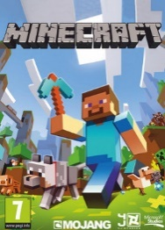Red Dead Redemption2 takes place in America at the end of the 1800s.

Resident Evil 6 takes place in in the USA.

Minecraft takes place in Terraria, which is an imaginary 2d world.

Can you make similar sentences?

S (The game) + **sets the player\*** + in + place: ubica o pone al jugador en…

↓ ↓ ↓ ↓

S. Mario Bross sets the player in the fictional land of the Mushroom Kingdom.

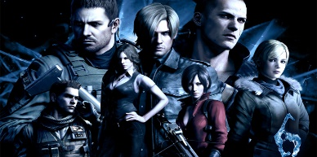 The game sets the player in the fictional land of the Mushroom Kingdom.

R. D. Redemption2 sets the player in America at the end of the 1800s.

Resident Evil 6 sets the player in in the USA.

Minecraft sets the player in Terraria, which is an imaginary 2d world.

Can you make similar sentences?

S (The game) + **is** **set \*** + in + place: se sitúa / se ubica en …

↓ ↓ ↓ ↓

S. Mario Bross is set in the fictional land of the Mushroom Kingdom.

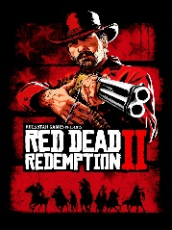 The game is set in the fictional land of the Mushroom Kingdom.

R. D. Redemption2 is set in America at the end of the 1800s.

Resident Evil 6 is set in in the USA.

Minecraft is set in Terraria, which is an imaginary 2d world.

Can you make similar sentences?

En todos los casos es posible ampliar la descripción del contexto, agregando una cláusula relativa, como podemos ver en los ejemplos de Minecraft (acá solo citaremos el primero):

Minecraft takes place in Terraria, **which is an imaginary 2d world.**

Otras opciones con relative clauses:

Super Mario Bros is set in the Mushroom Kingdom**, which is a monarchy ruled by Princess Peach.**

Red Dead Redemption sets the player in America at the end of the 1800s, **where the age of outlaws is in decline.**

Por ultimo queda describir el gameplay o game experience. (Atención acá **no** se habla de de lo que siente el jugador, **se habla de en qué consiste el juego**, **qué hay que hacer para ganar**). Esta parte es la más compleja porque no hay formas fijas para describirla como para las dos partes anteriores. Las formas van a variar de acuerdo al tipo de juego, personajes, etc.

Sin embargo hay expresiones como:

The player controls the main character/ protagonist.

The player must / has to…

The player can get…

The player scores a point when.

To win the game the player has to…

En muchos casos es posible cambiar ‘the player’, por el nombre del protagonista o personaje principal, o bien por las expresiones ‘the protagonist’ y ‘the main character’:

**The player has to** collect gems and lums scattered throughout the levels.

**The player controls the main character**, Trace. Trace is a student from the future.

¿Podés pensar en algún ejemplo?

Ya estamos en condiciones de estudiar una descripción:

1. Read the description and find the meaning of the words you do not understand:

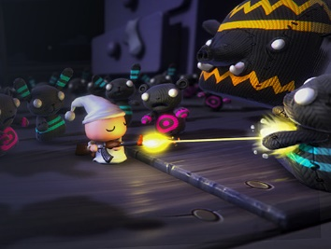ZombieToys is a third person survival game. It sets the Player in a magnified children’s room where the child is attacked by his /her zombified toys. The player must survive using his or her special remote-control toy, which has different tools. They can use the Lightning Ray, the Freeze Ray, drop a Stink Bomb or launch a Slime attack.

GLOSSARY:

2. Read the description again.

* 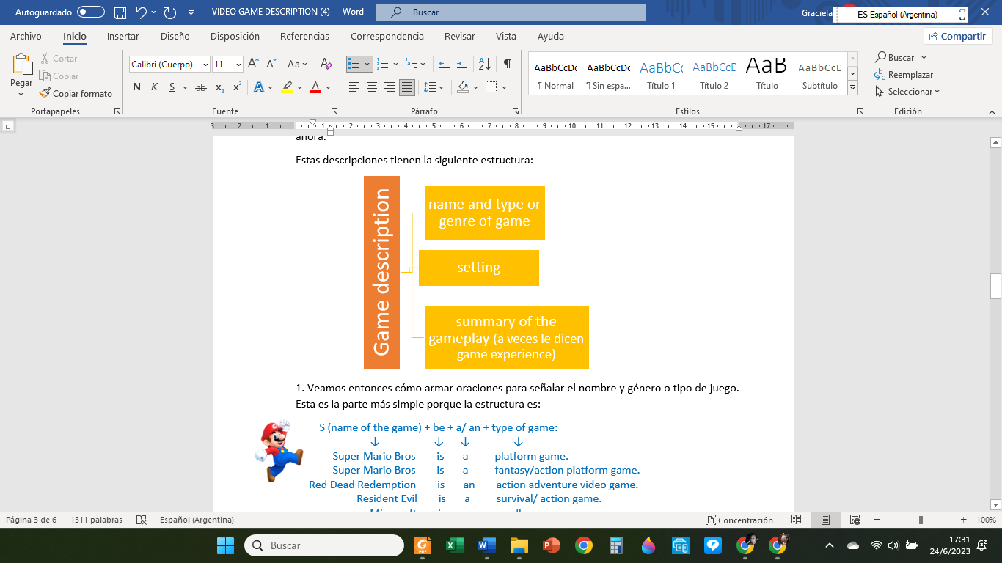Does it follow the structure previously mentioned?
* Can you distinguish the parts?
* Can you see subtitles?
* How many paragraphs does it have?

3. Look at another videogame description.

a. Work with the new words:

Glossary:

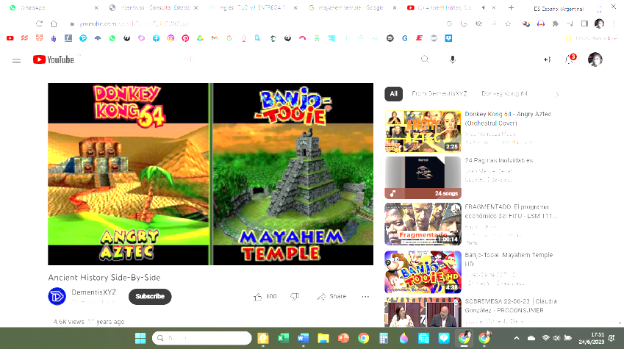b. Mayhem Temple: t different parts of the description are not in the correct place. Can you put it in the correct order?

The player controls a character whose name is Silva Grido and who is a treasure hunter. He has to overcome many challenges in Mayhem's Temple to get the treasure. The game is set in a fictional ancient temple, similar to a Mayan temple. Mayhem Temple is an action platform game, it's in 2D and uses pixel art.

4. Now, it is your turn. Think of your favorite video game and write its description. Use the following questions as a guide.

What is the name of your favorite video game?

What type of video game is it?

What is the gameplay (What does the player have to do to win)?